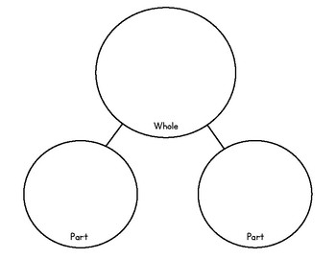
Cut out and use when needed for your child’s maths work.
If you run out, you can draw your own.

