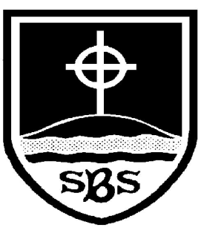 | St Bridget’s C of E Primary School  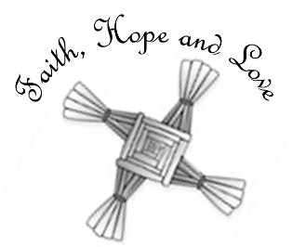  St Bridget’s Lane,  West Kirby,  Wirral CH48 3JT  Tel: 0151 625 7652  Headteacher: Mr Neil Le Feuvre  Email: schooloffice@stbridgets.wirral.sch.uk  Website: https://st-bridgets.eschools.co.uk/website
“Love your neighbour as yourself.”
Luke 10:27

Our Ref: Parl 1636

Dear Parents,
MILK FOR YEAR 1 CHILDREN – SPRING TERM
As you know children in Year 1 (Classes 1 & 2) are able to have milk at morning break if they wish. The cost for the whole term will be £6.20 which is payable via ParentPay.
In the past, the children have had small milk bottles with a straw which means throwing 250 plastic straws in the bin every week. As we are an eco-friendly school, we have now decided that we will give the children milk in a cup which will cut out a lot of the plastic waste.
If you do not wish for your child to have milk, please inform the year one team directly on year1comms@stbridgets.wirral.sch.uk . We have to order the milk in advance, therefore, please make the necessary payment on ParentPay by Friday 14th January to ensure we have sufficient milk for the children who would like it. Without payment, the children will be unable to have milk.
Many thanks,

Yours sincerely,

The Year 1 Team

