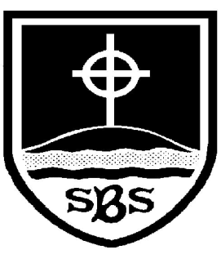 | St Bridget’s C of E Primary School  St Bridget’s Lane,  West Kirby,  Wirral CH48 3JT  Tel: 0151 625 7652  Headteacher: Mr Neil Le Feuvre  Email: schooloffice@stbridgets.wirral.sch.uk  Website: https://st-bridgets.eschools.co.uk/website
“Love your neighbour as yourself.”
Luke 10:27
Parl 1646

Update on Strike Action – Tuesday 2nd May 2023
Dear Parents/Carers,
I am writing to confirm that the school will be partially open on Tuesday 2nd May due to strike action. This is the result of a national pay dispute between Education unions and the government – it is not due to any actions taken by the school, and it is a matter for the unions and the government to resolve independently of the school.
To give you as much notice as possible the following year groups will be closed to pupils on Tuesday 2nd May:-
- Year 1- both classes
All other year groups will be open to pupils.
While we are doing all that we can to minimise disruption, I advise you to begin considering alternative childcare arrangements for Year 1 children, where needed, for this date.
Please note, a striking teacher cannot leave work for pupils to do, nor can another teacher teach their lessons.
I am sorry for any inconvenience this may mean to you and your child’s education, and I hope the dispute can be resolved as soon as possible.
Yours sincerely,

Neil Le Feuvre

