We’ll be serving you an evening of entertainment:
Don’t Forget: 1st March
St Bridget’s PA Wine tasting & St David’s day fun
Book your place by Wednesday 27th February

- Quality wine tasting and Quiz with experts from Chester Beer &Wine.
- Small plates featuring Welsh delicacies

Following the wine tasting event … the World’s first Welsheoke; a celebration of Welsh bands and singers through the power of Karaoke. Loads of fantastic anthems to choose from (or to watch) and featuring a Special Guest perfomance.

TICKETS £10 per person: Deadline Wednesday 27th February- please complete form below and return with payment (cash or cheques payable to St Bridget’s Parents’ Association) to the PA box in an envelope marked PA ‘Wine tasting’.

If you are unable to attend on the night, you can still support the school and the event by donating a Wine, Cheese or Welsh related prize for our raffle that evening. We will collect any donations from the school gates on Thursday 28^{th/} Friday 1st March 8.45-9am and 3.15-3.40pm. Thank you in advance, all donations will be gratefully received.
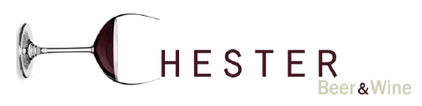

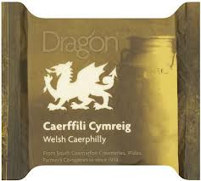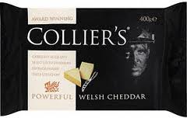

---------------------------------------------------------------------------------------------------------------------
Name
E mail address
Child’s Class _______________
I enclose £____________ for _____places.

