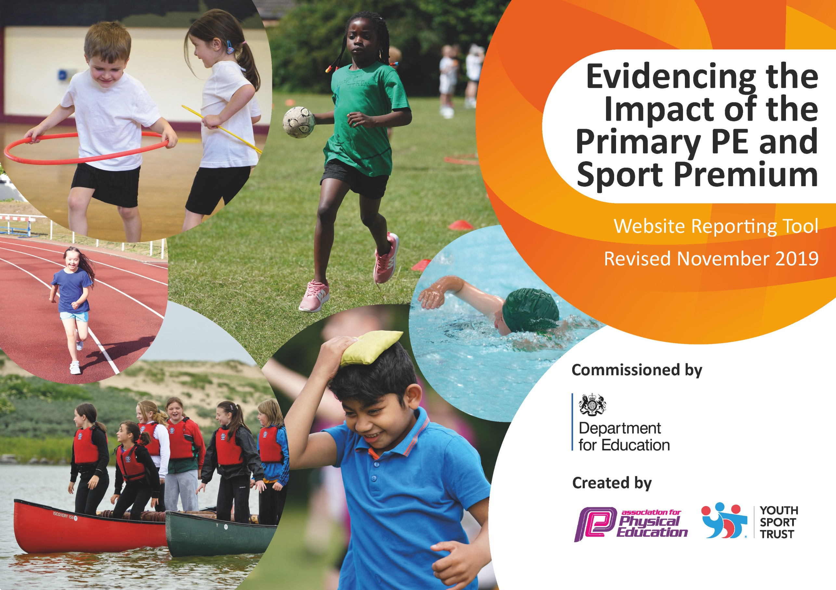
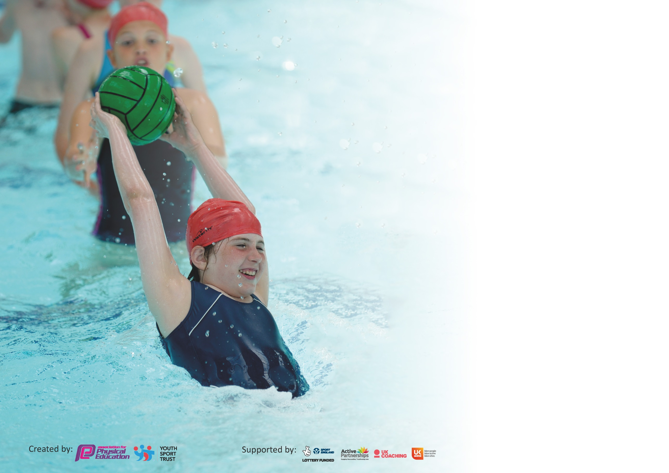

It is important that your grant is used effectively and based on school need. The Education Inspection Framework (Ofsted 2019 p64) makes clear there will be a focus on ‘whether leaders and those responsible for governors all understand their respective roles and perform these in a way that enhances the effectiveness of the school’.

Under the Quality of Education criteria (p41) inspectors consider the extent to which schools can articulate their curriculum (INTENT), construct their curriculum (IMPLEMENTATION) and demonstrate the outcomes which result (IMPACT).

To assist schools with common transferable language this template has been developed to utilise the same three headings which should make your plans easily transferable between working documents.

Schools must use the funding to make additional and sustainable improvements to the quality of Physical Education, School Sport and Physical Activity (PESSPA) they offer. This means that you should
use the Primary PE and Sport Premium to:

- Develop or add to the PESSPA activities that your school already offer
- Build capacity and capability within the school to ensure that improvements made now will benefit pupils joining the school in future years

Please visit gov.uk for the revised DfE guidance including the 5 key indicators across which schools should demonstrate an improvement. This document will help you to review your provision and to report your spend. DfE encourages schools to use this template as an effective way of meeting the reporting requirements of the Primary PE and Sport Premium.

We recommend you start by reflecting on the impact of current provision and reviewing the previous spend.

Schools are required to publish details of how they spend this funding as well as on the impact it has on pupils’ PE and sport participation and attainment by the end of the summer term or by 31st July 2020 at the latest.

We recommend regularly updating the table and publishing it on your website throughout the year. This evidences your ongoing self-evaluation of how you are using the funding to secure maximum, sustainable impact. Final copy must be posted on your website by the end of the academic year and no later than the 31st July 2020. To see an example of how to complete the table please click HERE.

Support for review and reflection - considering the 5 key indicators from DfE, what development needs are a priority for your setting and your pupils now and why? Use the space below to reflect on previous spend and key achievements and areas for development.

Key achievements to date until July 2021: | Areas for further improvement and baseline evidence of need:
School Gamesmark: Gold achieved for last 4 years  Very popular extra-curricular clubs funded by PE Premium  (80% of KS2 children, 81% KS1/F2 children attended at least one course 2018-19)  Opportunities for competitive sport beyond level 1. (86% KS2 chn represented St. Bridget’s 2018-19)  Teams qualified to represent Wirral at Cheshire/Liverpool City Region finals for Gymnastics (2018-19)  School Games Certification of Participation 2020 | Using PE and physical activity to support overall wellbeing – Personal Best Programme  Tracking engagement and participation – Edsential PE Passport  Staff training: New/Movement of staff means staff are teaching PE for first time/ different age groups.  Continue to target least active children to engage in physical activity.  Edsential Bespoke Package Purchased. Total £7317.75  PE Subject Leader Support  PE Curriculum Design  Fundamentals Programme  Rainbow Project- Yoga based intervention  New scheme of work  Breakfast and After School Clubs Carried over £5400  Personal Best 6 sessions  PE Passport 1 year subscription  Y5 Playmaker training- carried over £675

Meeting national curriculum requirements for swimming and water safety.
What percentage of your current Year 6 cohort swim competently, confidently and proficiently over a distance of at least 25 metres?  N.B. Even though your pupils may swim in another year please report on their attainment on leaving  primary school at the end of the summer term 2020. | %94
What percentage of your current Year 6 cohort use a range of strokes effectively [for example, front crawl, backstroke and breaststroke]? | %89
What percentage of your current Year 6 cohort perform safe self-rescue in different water-based situations? | %92
Schools can choose to use the Primary PE and Sport Premium to provide additional provision for swimming but this must be for activity over and above the national curriculum requirements. Have you used it in this way? | Yes/No  No due to covid

Action Plan and Budget Tracking
Capture your intended annual spend against the 5 key indicators. Clarify the success criteria and evidence of impact that you intend to measure to evaluate for pupils today and for the future.

Academic Year: 2020/2021 | Total fund allocated: £19820 and £1656 (previous year spend has been highlighted)  Total spend: £16145.75  Under spend: £3674.25 to be carried over. 18% underspend. | Date Updated: 15/07/21
Key indicator 1: The engagement of all pupils in regular physical activity – Chief Medical Officer guidelines recommend that primary school pupils undertake at least 30 minutes of physical activity a day in school |  |  |  | Percentage of total allocation:
 |  |  |  | %
Intent | Implementation |  | Impact | 18
Your school focus should be clear what you want the pupils to know and be able to do and about  what they need to learn and to  consolidate through practice: | Make sure your actions to achieve are linked to your intentions: | Funding allocated: | Evidence of impact: what do pupils now know and what can they now do? What has changed?: | Sustainability and suggested next steps:
Active play Activities and encourage a wider range of children, esp girls and reluctant participants- keeping active (on hold currently due to staggered playtimes-covid)  Use of physical activity in the classroom  Swimming Key stage 2- Years 3, 4, 5, 6 | Play Leader training will ensure that all children during lunch times have the opportunity to engage in structured physical activity.  Playmaker Award to play leaders- Year 5 children Play Maker Award Training (will be year 6 next when training takes place.)  Dedicated Play leaders - (adult only due to Covid)  Staff to use online resources such as BBC Supermovers, Cosmic Yoga, Change for life activities.  KS2 Physical challenge activities for use when games lessons cancelled due to wet weather  Swimming to take place at local leisure centre- | £ On going surplus PE carry over due to Covid- July 2022  £675-carried over  £2960  £0 | Subject Leader will monitor and evidence engagement with lunch time activities across the year. Meeting with RR to discuss future practise.  Non- Due to covid.  Online tool to encourage Physical Activity during Lockdown and limited interactions during covid.  Autumn 2020 dates cancelled due to pool closure/local lockdown measure.  Spring- Waiting on guidance due to Covid 19 restrictions.  Summer- Year 4, 5 priorty swimmers. Year 4 as missed swimming in year 3 and year 5 to collate data for year 6.  Update- swimming for spring/Summer 2021 cancelled due to Covid-Subject Lead and Headteacher decision. | ASAP-implementation across all key stages when spacing allows.  Identified 2 members of staff and training scheduled for next academic year.  Play leaders to train peers. More efficient use of playleaders leading games.  Continue to promote with Staff.  Swimming to be a priority September 2021- Year 6 to swim in Autumn  Term 1.
Key indicator 2: The profile of PESSPA being raised across the school as a tool for whole school improvement |  |  |  | Percentage of total allocation:
 |  |  |  | %
Intent | Implementation |  | Impact | 9
Your school focus should be clear what you want the pupils to know and be able to do and about  what they need to learn and to  consolidate through practice: | Make sure your actions to achieve are linked to your intentions: | Funding allocated: | Evidence of impact: what do pupils now know and what can they now do? What has changed?: | Sustainability and suggested next steps:
To offer wide range of sporting opportunities to children for both physical and mental health benefits as well as personal development  School Games Mark  Aim to retain Gold Status and work towards Platinum Level.  Pupils engaged in planning of PE and school Sports.  Track Participation across school. | Personal Best  Competitions- In house competitions due to Covid.  Preparation of data for Goldmark application. Case study for Platinum application.  Pupil Voice to monitor pupil feedback and inform future planning-.  PE Passport  Depth of learning. | 1049.95- (1656-carried over from 2019/2020)  £0  £638.80- (606.05- carried over from Previous year) | Baseline questioning before starting- same questioning when completing.  To  Feedback-verbal and pupil voice.  Roll out whole school use of PE Passport. Postpone until Jan 2021 Deputy head at request due to staff well-being and work load.  Postponed roll out due to lockdown Spring term.- review effectiveness of passport. Summer term- decided not to roll out P.Passport- plan to use alternative assessment tool- currently using DOL. | Children physical and mentally healthy - resilient and engaged with learning.  Children adopt lifelong healthy lifestyles.

Key indicator 3: Increased confidence, knowledge and skills of all staff in teaching PE and sport |  |  |  | Percentage of total allocation:
 |  |  |  | %
Intent | Implementation |  | Impact | 27
Your school focus should be clear | Make sure your actions to | Funding | Evidence of impact: what do | Sustainability and suggested
what you want the pupils to know | achieve are linked to your | allocated: | pupils now know and what | next steps:
and be able to do and about | intentions: |  | can they now do? What has
what they need to learn and to |  |  | changed?:
consolidate through practice:
Whole school staff CPD  Improved quality of children's physical education in Key Stage 1/2 to ensure staff are competent and confident.  Fundamentals EYFS CPD training  Subject leader update/networking  Professional development in subject leadership for PE subject leader.  PE Subject lead/Curriculum Design/  Improve standards of teaching and learning across the school- areas of weakness for staff- progression and differentiation in PE.  Edsential to introduce the Rainbow project to ks1 year 2 staff in spring 1. It is a blend of yoga and mindfulness and self-regulating techniques | Staff CPD Swimming teaching 2-day course (AH/AC/LC)  Access Subject leader training/conferences & updates as available during the year  CPD with a sport specialist. 6 weeks course looking at children’s development.  All staff to be aware of and use the new 2020 Wirral scheme of work.  Introduce/made aware of the progression tables to make sure that progress is being seen across the school- linked to milestones and threshold concepts.  Ks1 staff will stay in for CPD. Weekly hour session sessions-whole class for 12 weeks. Class teacher is given tasks that can be completed within the class environment. Update- 2 sessions a week continued in Spring 2 to complete missed sessions due to Covid. | £468.00- carried over  £840  £84.00-Summer Term- Edsential package.  £600- Supply  £1390-  £2040.00 | Improved quality of teaching, Legal requirement of adult-pupil ration for class over 30 pupils  Subject Leader up-to-date with information needed for curriculum improvement/development and sporting opportunities available.  Goss moor and fine motor skills development. See Report from Edsential.  Staff feedback.  Curriculum design, professional development and assessment design.  Staff will be able to roll out the programme at no cost next year as they have the CPD and additional course material. Transferable skill set. | 3 more staff now with up to date qualifications.  PE Subject Leader monitor and provide support as appropriate in order to ensure progress and achievement are maintained by all pupils.  Transferable skills- across EYFS to Year 1.
Key indicator 4: Broader experience of a range of sports and activities offered to all pupils |  |  |  | Percentage of total allocation:
 |  |  |  | %
Intent | Implementation |  | Impact | 27
Your school focus should be clear | Make sure your actions to | Funding | Evidence of impact: what do | Sustainability and suggested
what you want the pupils to know | achieve are linked to your | allocated: | pupils now know and what | next steps:
and be able to do and about | intentions: |  | can they now do? What has
what they need to learn and to |  |  | changed?:
consolidate through practice:
Additional achievements:  Virtual whole school competitions  Investigate funding for outdoor improvements for a track on the school field.  Retain high percentage of children participating in breakfast and after school clubs | Edsential Virtual Competitions – each weekly competition has a different focus.  Lunch time engagement – Play Leaders will ensure that throughout the year, children are given the opportunity to take part in a broad range of activities during lunch times.  Use subject leader time to investigate provides and costs for improvements.  Edsential package- extra-curricular courses | NA  NA  £5400 Carried | Edsential PE Passport will be used to track participation and engagement in competitions. Roll out postponed due to Covid.  Subject Leader observations and Pupil Voice will be used to measure the impact of Play Leaders on engagement.  Whole school participation, resilience and participation- encourage daily exercise.  Not completed due to Covid. | Playmaker award for further training and involvement of the children.  Increase in staff run clubs for free where willing.  Introduction of paid courses to reduce cost to school and to evaluate effect on participation in anticipation of PE Premium ending.

Key indicator 5: Increased participation in competitive sport |  |  |  | Percentage of total allocation:
 |  |  |  | %
Intent | Implementation |  | Impact | 0
Your school focus should be clear | Make sure your actions to | Funding | Evidence of impact: what do | Sustainability and suggested
what you want the pupils to know | achieve are linked to your | allocated: | pupils now know and what | next steps:
and be able to do and about | intentions: |  | can they now do? What has
what they need to learn and to |  |  | changed?:
consolidate through practice:
In house competitions- ran by Edsential- participation-team building. | Whole class engagement- including SEND children- fully inclusive challenges. | N/A | Recorded on Twitter-leader board published weekly. Pupils are very eager to complete challenges- working on collaboration not personal gain.  Edsential PE Passport will be used to track participation and engagement. | To encourage whole school participation.

Signed off by
Head Teacher:
Date:
Subject Leader: | Lyndsay Daltrey
Date: | 16/07/21
Governor:
Date:

