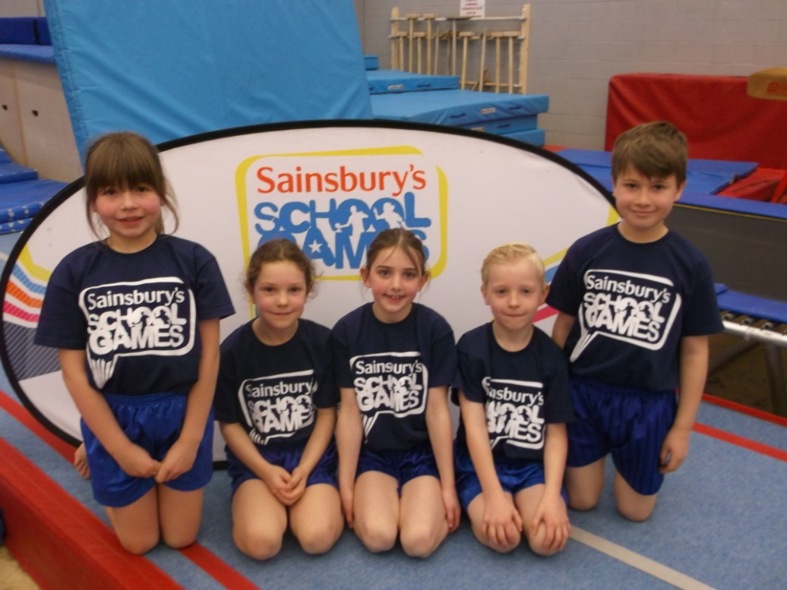

Our year 3 gymnastics team represented the school and Wirral in the primary gymnastics Merseyside County final. It was a tough competition with 14 schools taking part from all over Merseyside. The children should be very proud of themselves as they all performed extremely well but on this occasion they did not come in the top 3. They should not be disappointed as it was a fantastic experience and they even got to meet a professional gymnast who told us all about her gymnastic career!
