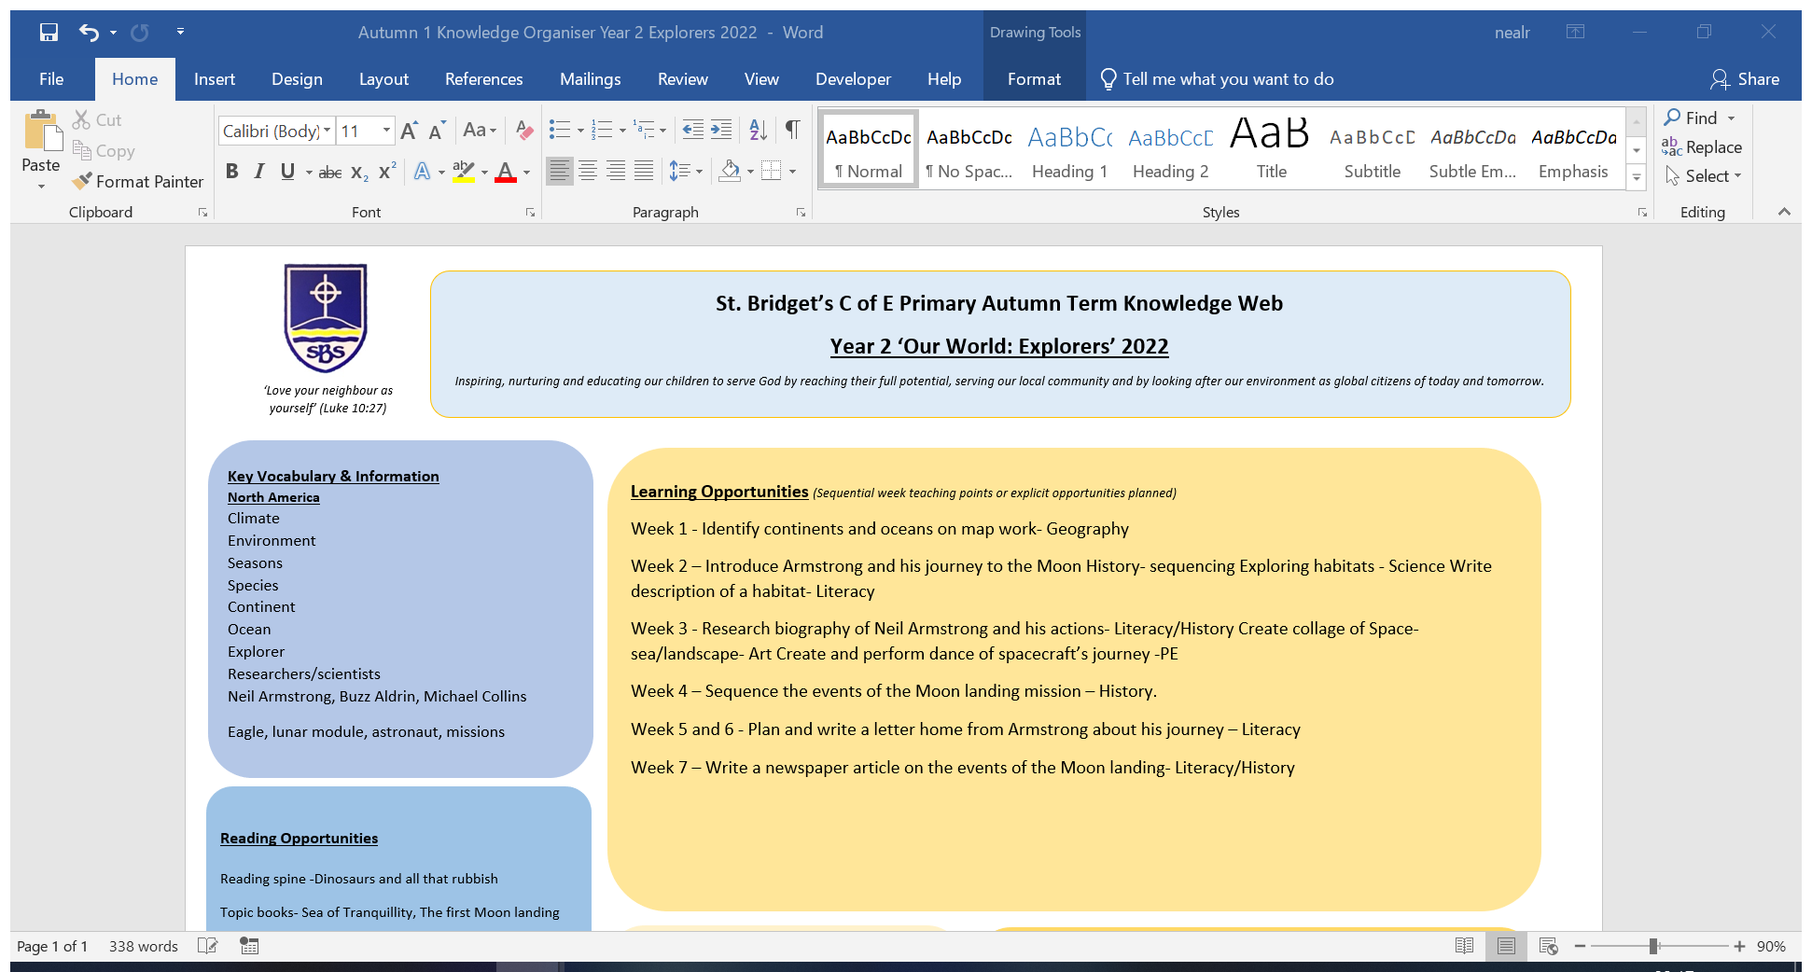

| **Year Group** | **Autumn Term (Our World)** | **Spring Term (Our Community)** | **Summer Term (Our Environment)** | **Fieldwork Visit** |
| --- | --- | --- | --- | --- |
| EYFS | My local area: Seasonal change  Environmental habitats for animals around the world. | My local area: Seasonal change  Life in the UK compared to other countries e.g. Chinese New Year. | My local area: Seasonal change  Mapwork: Finding our school on a map. | School grounds and local walks |
| Y1 | The United Kingdom: Countries, capitals and surrounding seas. Our seasons and weather patterns. | Mapwork exploring the human and physical Geography of our school. | Local Area study: West Kirby | School grounds and our Church |
| Y2 | Our World: Continents and Oceans, hot and cold areas including the Equator and the Poles. | Mapwork: Non-European country study: Australia. | Local Area study: The human and physical geography of our local area. | Ashton Park |
| Y3 | Locational Geography: The counties and cities of the UK including identifying the human and physical characteristics. | Mapwork exploring the UK coastline and its resources. | Local Area study: The River Dee and Erosion of the local coast | Thurstaston |
| Y4 | Locational Geography: The land use of the UK and the change of it over time. | Mapwork exploring trade within the UK. | Local Area Study: The Wirral and River Mersey  The Water Cycle. | Hilbre Island |
| Y5 | Locational Geography: Landforms in Europe, including mountains and earthquakes, and their impacts. | Mapwork exploring Europe including 4 figure grid referencing. | Local Area and European Area Study: Rome.  Volcanoes. | Chester and the River Dee |
| Y6 | Locational Geography: North and South America including the environmental regions, key physical and human features and countries and cities. | Mapwork exploring the World including 6 figure grid referencing.  North America Area Study: New York City | Local Area Study: Climate Change: Erosion and deposition management with a focus on West Kirby. | West Kirby |