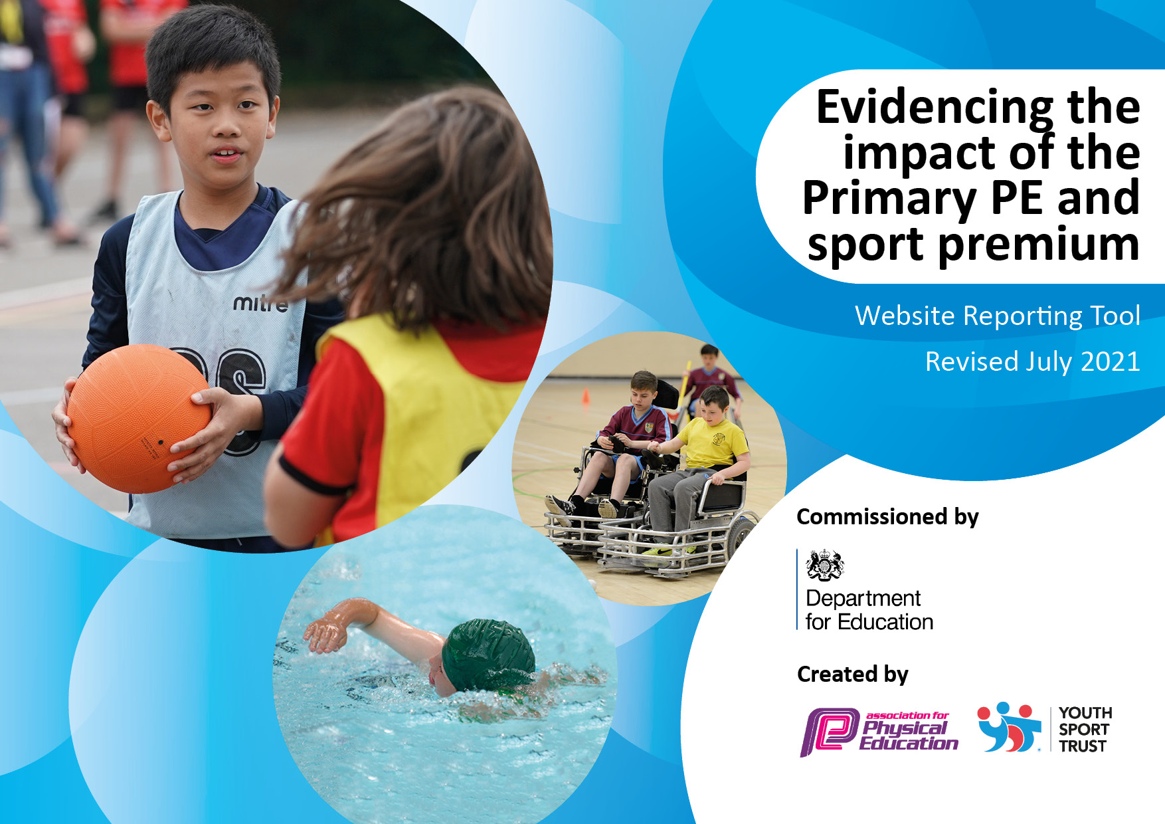
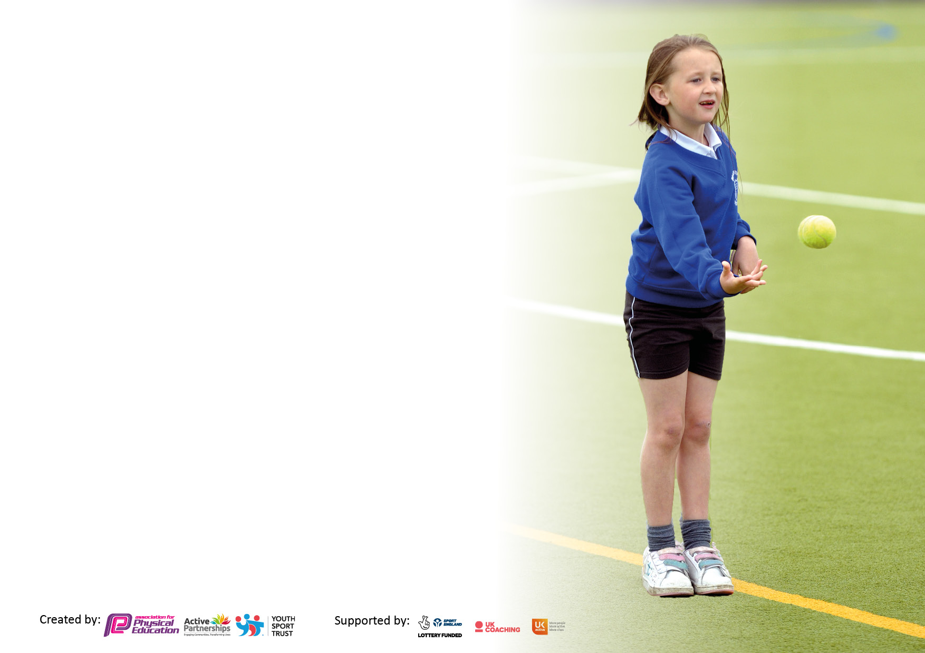

It is important that your grant is used effectively and based on school need. The Education Inspection Framework makes clear there will be a focus on ‘whether leaders and those responsible for governors all understand their respective roles and perform these in a way that enhances the effectiveness of the school’.

Under the Quality of Education Ofsted inspectors consider:
Intent - Curriculum design, coverage and appropriateness
Implementation - Curriculum delivery, Teaching (pedagogy) and Assessment
Impact - Attainment and progress

To assist schools with common transferable language this template has been developed to utilise the same three headings which should make your plans easily transferable between working documents.

Schools must use the funding to make additional and sustainable improvements to the quality of Physical Education, School Sport and Physical Activity (PESSPA) they offer. This means that you should use the Primary PE and sport premium to:

- Develop or add to the PESSPA activities that your school already offer
- Build capacity and capability within the school to ensure that improvements made now will benefit pupils joining the school in future years
- The Primary PE and sport premium should not be used to fund capital spend projects; the school’s budget should fund these.

Pleasevisitgov.ukfortherevisedDfEguidanceincludingthe5keyindicatorsacrosswhichschoolsshoulddemonstrate animprovement.Thisdocumentwillhelpyoutoreviewyourprovisionandtoreportyourspend.DfEencouragesschools to use this template as an effective way of meeting the reporting requirements of the Primary PE and sport premium.

We recommend you start by reflecting on the impact of current provision and reviewing the previous spend.

Schools are required to publish details of how they spend this funding, including any under-spend from 2019/2020, as well as on the impact it has on pupils’ PE and sport participation and attainment. All funding must be spent by 31st July 2022.

We recommend regularly updating the table and publishing it on your website throughout the year. This evidences your ongoing self-evaluation of how you are using the funding to secure maximum, sustainable impact. Final copy must be posted on your website by the end of the academic year and no later than the 31st July 2021. To see an example of how to complete the table please click HERE.
Created by: Supported by:

Details with regard to funding
Please complete the table below.

Total amount carried over from 2021/22 | £0
Total amount allocated for 2022/23 | £19740
Total amount of funding for 2022/23. To be spent and reported on by 31st July 2022. | £19740
Swimming Data
Please report on your Swimming Data below.

Meeting national curriculum requirements for swimming and water safety.  N.B. Complete this section to your best ability. For example you might have practised safe self-rescue techniques on dry land which you can then transfer to the pool when school swimming restarts.  Due to exceptional circumstances priority should be given to ensuring that pupils can perform safe self rescue even if they do not fully meet the first two requirements of the NC programme of study | 95%
What percentage of your current Year 6 cohort swim competently, confidently and proficiently over a distance of at least 25 metres?  N.B. Even though your pupils may swim in another year please report on their attainment on leaving primary school at the end of the summer term 2023.  Please see note above | 95%
What percentage of your current Year 6 cohort use a range of strokes effectively [for example, front crawl, backstroke and breaststroke]?  Please see note above | 98%
What percentage of your current Year 6 cohort perform safe self-rescue in different water-based situations? | 95%
Schools can choose to use the Primary PE and sport premium to provide additional provision for swimming but this must be for activity over and above the national curriculum requirements. Have you used it in this way? | Yes-£1680

Action Plan and Budget Tracking
Capture your intended annual spend against the 5 key indicators. Clarify the success criteria and evidence of impact that you intend to measure to evaluate for pupils today and for the future.

Academic Year: 2022/23 | Total fund allocated: | Date Updated:17/07/23
Key indicator 1: The engagement of all pupils in regular physical activity – Chief Medical Officers guidelines recommend that primary school pupils undertake at least 30 minutes of physical activity a day in school |  |  |  | Percentage of total allocation:
 |  |  |  | 52% total spend-£10280
Intent | Implementation |  | Impact
Your school focus should be clear what you want the pupils to know and be able to do and about  what they need to learn and to  consolidate through practice: | Make sure your actions to achieve are linked to your intentions: | Funding allocated: | Evidence of impact: what do pupils now know and what can they now do? What has changed?: | Sustainability and suggested next steps:
Active play Activities to increase the number of pupils who are regularly active on the playground.  (Regular – 3 times a week)  Target of 85% of pupils regularly active. | Play Maker Award Training for Year 6 pupils. Support will be via termly drop in sessions to support play leaders and staff during lunch times.  Allocated staff member employed to facilitate and raise the profile of physical activity during playtimes. | £600  £4000 | Impact: Subject Leader will monitor and evidence engagement with lunch time activities across the year.  Deputy Head- also monitoring participation of engagement.  All school facilities are utilised. Clubs are run before and after school wither on the playground/field or hall.  Lunch time activities are available on both playgrounds- supported by play leaders/staff.  More children are engaging with the school competitions- generating a love of a sport- possible netball, basketball and football clubs supported by parents.  Evidence:  Pupil feedback and staff observations  Lunch times – Play Leader feedback and observations of staff  Photo evidence on G.drive.  LA advisor visit- Observation of how playground activities were used- positive feedback. | Edsential support staff to check in- possible scope for additional support if needed- booked for Spring 2. This year’s staff will implement previous training and training next year 5 cohort reading to support active play in year 6.  Before and after school clubs to continue and raise the profile of sporting activities.  Continuation of inter school competitions and links with other schools, resulting in more children representing St Bridget’s Primary.  To continue to raise the profile of active play, encourage peer on peer participate and transferable skills through interact, demonstration and practice.  Introduce Sports Captain/Sporting Council.
Increase attendance of the least active pupils at before and after school activity clubs.  65%+ of whole school attending at least 1 x after school or breakfast activity cub by July 2023. | Use clubs from external providers to supplement those delivered by school staff.  Monitor and identify pupils not engaged and use specific clubs to support their participation. | £4090 (Edsential) | Impact: Clubs are oversubscribed termly and additional clubs are being booked to support the demand.  Evidence: Sports and skills on offer are selected and bespoke to each year group through pupil voice, to ensure maximum participation and interest. Registers are taken. Sports celebration wall documents clubs taking place termly to excite children across the key phases.  Pupil voice and what children would like to see as an extra-curricular offer. Subject leader was then able to amend proposed offer to encompass the outcomes.  Participation across school.  EYFS- All children offered a club- 67% attended club- Autumn term will be dedicated to encourage children not accessing. Low percentage due to EYFS children not accessing clubs until Spring term- When children reach Year 1 they will be priority.  All children have been offered a variety of extra-curricular clubs.  Year 1- 82% attended.  Year 2- 83% attended  Year 3- 63% attended  Year 4- 77% attended  Year 5- 75% attended  Year 6- 81% attended  School participation of a before and after school club-72% of whole school attending a before/afterschool club.  School participation of a before/afterschool club including competitions- 75%. | Continue to monitor participation and pupil voice for possible clubs. Making links and connections with other outside agencies.  Archery-is a new feature on our extra-curricular offer.  Parental involvement- 3 potential clubs to run and supported by Subject leader- Basketball, girls’ football and Netball- possible links with other schools to run competitions and friendlies.  To continue with the increased clubs delivered by Edsential and to run at least 3 additional outside agency clubs. Possible scope for ECT to deliver clubs throughout the year.  To continue to monitor outside of school hour physical activity via Google forms. To collate information and add to participation tracker. This will enable us to have a clearer picture of the whole child not just want is achieved in school.  Year 3 moving into Year 4 will be targeted to raise the profile of participation. They will be offered the clubs they have recorded as desirable from pupil voice from Autumn 1 2023.
Improve the fundamental movement skills of pupils in EYFS. Target of 80% of all FS2 Pupils to reach GLD in Physical development.  Consolidating the fundamental movement skills of pupils in Year 1. Target of 80% of all Pupils to reach expected in Physical Education. | Edsential Fundamentals Programme:  6-week programme aimed at developing fundamental movement skills/ physical literacy of children in Year 1 who did not meet the ELG for physical development and those in F2 who are at risk of not meeting it this year.  Edsential Fundamentals Programme:  6-week programme aimed at developing fundamental movement skills/ physical literacy of children in Year 1 who did not meet the ELG for physical development and those in F2 who are at risk of not meeting it this year. | £1590- for EYFS and Year 1. | Impact: All children to be physically active across FS2- small groups working with the sports specialist.  Evidence: Targeted children will develop better skills in fine motor such as using scissors and handwriting. In gross motor skills they will begin to navigate the classroom easier resulting in fewer bumps. They will be able to have easier access to PE lesson skills- raising the awareness of agility, special reasoning, perseverance and resilience.  LB- 28/30 children achieved GLD in Gross motor 93%  BB- 29/30 children achieved GLD in Gross motor 97%.  Impact: Raising the profile of fundamental skills and development. Smaller groups- 15 children max to really embed the physical, thinking and personal/health development through quality first teaching of a skill and language.  Evidence: Pupil voice- all children thoroughly enjoyed the lessons and participated well- documented in class floor book. (formative assessment) Teacher assessment- children using the correct terminology and language when evaluating lessons. DOL- All children assessed at meeting basic 1 level Games. | Staff completed assessments and team taught with coaches.  Transferrable skills- used in Sports day to demonstrated skills and growth.  Fundamentals skills was taught again after the CPD was delivered to consolidate skills.  CPD support Edsential online plans. Class teachers to run programme in 23/24 academic year- Transferable skill set.
Key indicator 2: The profile of PESSPA being raised across the school as a tool for whole school improvement |  |  |  | Percentage of total allocation:
 |  |  |  | 18%- total spend £3640
Intent | Implementation |  | Impact
Your school focus should be clear what you want the pupils to know and be able to do and about  what they need to learn and to  consolidate through practice: | Make sure your actions to achieve are linked to your intentions: | Funding allocated: | Evidence of impact: what do pupils now know and what can they now do? What has changed?: | Sustainability and suggested next steps:
Improve self-esteem and resilience of identified groups of pupils.  All pupils accessing to demonstrate improvements. (100%) | Personal Best Programme delivered to identified pupils in each year group.  Year 2, Year 3. Year 5 and Year 1. | £3640 | Impact: Reports given by Edsential  Impact on all areas of subject  including participation, quality of  teaching, etc.  Evidence: Personal best to be delivered to Year 2 and Year 3 in Spring Term and Year 1 in Summer.  Spring 1- Year 2  Headline data- resilience 82% feel more resilient, 82% increased confidence and 91% enjoyment.  Spring1- Year 3  Headline Data- 81% feel more resilient, 50% always feeling confident and 50% sometimes feeling confident- an increase of 13% and 89% enjoyment.  Summer 1- Year 5  Headline Data- 74 % resilience, 76% confidence and 74% enjoyment.  Summer 2- Year 1  Headline data-83% feel more resilient, 76% more confident and 90% enjoying physical activity. | Children’s physical and mental health- resilient and engaged with learning.  Children developing and adopting lifelong healthy lifestyles.  To develop a love of a sport and the confidence to strive to achieve the best- leading onto more areas of school and personal life.  4 sessions have been booked in for the next academic year.  Data and children’s comments have been shared with SENCO and PHSE lead.
Develop and improve resilience  Self-Awareness and self-managing of Positive Mental Health | CPD sessions for identified classes as part of The Rainbow Programme. Yoga based sessions with a focus on raising self-awareness and promoting technique for self-management | £1750 (booked and paid for last year) | Impact: Impact report saved on G.Drive.  Evidence: Report given on completion. Headline:  Following the programme, there was a 47% increase in the number of children who reported  they 'were always a nice person'. (Positive mental health).  • There was a 64% increase in the number of children who reported they can 'always'  recognise when their feelings changed (self-awareness).  • Following the programme, there was a 56% increase in the number of children who  reported they 'always knew what to do when things were difficult' (resilience). | All children participated- The Rainbow Project has been very successful and had a huge impact on mental health, resilience and understanding of emotions. It will be delivered to Year 5 2023/24.

Key indicator 3: Increased confidence, knowledge and skills of all staff in teaching PE and sport |  |  |  | Percentage of total allocation:
 |  |  |  | 5%- total spend £988
Intent | Implementation |  | Impact
Your school focus should be clear | Make sure your actions to | Funding | Evidence of impact: what do | Sustainability and suggested
what you want the pupils to know | achieve are linked to your | allocated: | pupils now know and what | next steps:
and be able to do and about | intentions: |  | can they now do? What has
what they need to learn and to |  |  | changed?:
consolidate through practice:
Increase attainment of all pupils in curriculum PE | CPD sessions with PE specialist using identifying areas for development  Staff have increased knowledge and can teach high quality physical education in arrange of activities appropriate to pupils ‘age groups.  Consistently good PE teaching across the school ensuring all children have access to quality physical education.  Sustainable activity through staff  continuous professional learning leading to continued delivery of high-quality physical education.  Enhanced, inclusive curriculum provision.  More confident and competent staff.  Enhanced quality of teaching and learning.  Subscription to online scheme of work to support sequential teaching across all areas of the PE Curriculum. | £3640-paid last year.  £288 | Impact: Subject Leader up-to-date with information needed for curriculum improvement/development and sporting opportunities available. Impact evident in all other areas of this document.  Evidence: Curriculum design, professional development and assessment design.  Progression of skills through each key stage. Floor books now used to document children’s learning journey- formative assessment taking place after each lesson/explicit skill being taught and recorded.  DOL- Data recorded termly and monitored by subject leader.  Pupil voice and annotations recorded in floor book via teachers’ observations or own reflections.  Lesson Observations  PE Planning and Assessments Photographs and videos from lessons Staff CPD records. | PE Subject leader monitor and provide support as appropriate in order to ensure progress and achievement are maintained by all pupils.  Area for development- ECT staff- additional CPD booked for 23/24.  Plans are very effective and easy to use. Staff have been made aware of the knowledge organisers and retrieval of prior learning. PE floor books very successful for formative assessment and reflection- to be continued into the next academic year.
Subject Leader to stay up to date with local and national developments within area.  Children will become more active by attending clubs.  Impact on all other areas including increased participation, improved teaching and learning and effective use of PE funding. | Edsential Subject Leader Support Programme:  Termly meeting to support PE Subject Leader  Ongoing advice and guidance  Analysis of participation  Learning Walks and Observations | £700 | Impact: - Subject Leader up-to-date with information needed for curriculum improvement/development and sporting opportunities available. Impact evident in all other areas of this document.  Evidence: Improve and provide quality first teaching for all pupils. Progress will be seen in termly data. | Subject Leadership support to continue for next academic year.

Key indicator 4: Broader experience of a range of sports and activities offered to all pupils |  |  |  | Percentage of total allocation:
 |  |  |  | 13%- total spend £2471.12
Intent | Implementation |  | Impact
Your school focus should be clear | Make sure your actions to | Funding | Evidence of impact: what do | Sustainability and suggested
what you want the pupils to know | achieve are linked to your | allocated: | pupils now know and what | next steps:
and be able to do and about | intentions: |  | can they now do? What has
what they need to learn and to |  |  | changed?:
consolidate through practice:
Increase the number of Year 6 pupils leaving the school as competent swimmers  Equipment purchase to support the high- quality learning and delivery of lessons. | Purchase additional top up lessons for any pupils that have not yet achieved the expected standard.  Purchase of equipment to replace worn and well used equipment.  EYFS/KS1/KS2 Active play equipment has been purchased. | £1680  £791.12 | Impact: Full report stored on the G.Drive.  Additional swimming lessons to be completed in Year 6 for children not meeting NC. Small class sessions and a bespoke curriculum to be created by targeting children’s individual targets. To take place Summer term.  Evidence:  28 children did not meet NC in Year 5 and completed top swimming lessons in Year 6.  Headline data:  2021/23 Current year 6 data- 81% met the standard of swimming 25m- after top up swimming in 2022/23 95%, increase of 14%.  Self-rescue 75%, after top up swimming 95%, an increase of 20%.  Range of strokes 76% after top up swimming 98%, an increase of 22%.  Meeting NC in 2021/22- 68% after top up swimming in 2022/23- 95%.  27% increase.  Children have access to equipment to develop skills throughout their lessons to enable progression. | To continue top up sessions for Year 6 children that have not achieved NC in Year 5. To bridge the gaps and water safety in line with our intent in 2023/24. Swimming session will be for 1 week only.  To continue to store and manage equipment safely.

Key indicator 5: Increased participation in competitive sport |  |  |  | Percentage of total allocation:
 |  |  |  | 2%- total spend £300
Intent | Implementation |  | Impact
Your school focus should be clear | Make sure your actions to | Funding | Evidence of impact: what do | Sustainability and suggested
what you want the pupils to know | achieve are linked to your | allocated: | pupils now know and what | next steps:
and be able to do and about | intentions: |  | can they now do? What has
what they need to learn and to |  |  | changed?
consolidate through practice:
Increase the number of pupils accessing intra and inter competitions with particular focus on pupil premium, SEND and our least active pupils.  Target of 50% of all KS2 pupils to represent the school in inter competitions.  100% of pupils to take part in termly intra competitions through PE lessons. | Intra/Inter competitions commencing Spring 2022. Highlighting children not signing up for clubs- Focus on PP/SEND/FSM  Pupil Voice to monitor pupil feedback and inform future planning-. | Included with Edsential Service  Supply cover: £300 | Impact: Inclusion for all children- no barriers.  Impact to be measured once competitions are completed.  Evidence: Competition dates are booked throughout the academic year. Tracked on the whole school participation tracker and impact is saved on G.drive.  KS2 inter competitions from Year 4 onwards- 93 children out of 187 children- 50 %  PP pupils -9 children 36 %  SEND Pupils- 12 children- 41 %  FSM- 5- 45 %  School Game Mark- Gold Award achieved 2022-2023. | To embed and develop a love of a potential sport. To increase participation.  Making sporting opportunities accessible to all.  Moving forward address staff involvement to facilitate sporting competitions.
Total spend- £17567.02
Carried over to 2023/24- £2060.88

Underspend 10%

Signed off by
Head Teacher: | N LeFeurve
Date: | 21/07/23
Subject Leader: | L Ashton
Date: | 18/07/23
Governor:
Date:

