ST BRIDGET’S C of E PRIMARY SCHOOL

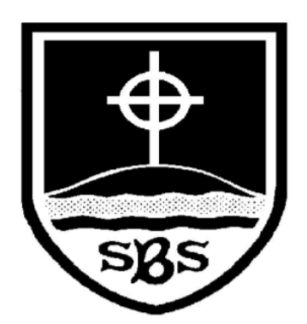

SEND
Policy

'Love your neighbour as yourself,' (Luke 10:27)

Approved by: | SLT & Governors | Date: September 2025
Last Reviewed and updated on: | September 2025 | SENCO: Alexander Coughlin
Next review due by: | September 2026 | Contact: senco@stbridgets.wirral.sch.uk

CRC Links

Article 2 (Non-discrimination): All children have these rights, no matter who they are, where they live, what their parents do, what language they speak, what their religion is, whether they are a boy or girl, what their culture is, whether they have a disability, whether they are rich or poor. No child should be treated unfairly on any basis.

Article 3 (Best interests of the child): All adults should do what is best for the children. When adults make decisions, they should think about how their decisions will affect children.

Article 12 (Respect for the views of the child): Children have the right to give their opinion, and for adults to listen and take it seriously.

Article 24 (Health and health services): Children have the right to the best health care possible, safe water to drink, nutritious food, a clean and safe environment, and information to help them stay well.

Article 29 (Goals of education): Children’s education should help them use and develop their talents and abilities. It should also help them learn to live peacefully, protect the environment and respect other people.

Article 32 (Child labour): Children have the right to protection from work that harms them, and is bad for their health and education.

Contents
1. Aims 3
2. Legislation and guidance 3
3. Definitions 3
4. Roles and responsibilities 3 - 3
5. SEN information report 4 - 8
6. Monitoring arrangements 9
7. Links with other policies and documents 9

1. Aims

At St Bridget’s CofE Primary School we recognise that any child at any time may require extra support. There may be many reasons for this: learning, physical, emotional or behavioural difficulties or the possession of special aptitudes that need to be nurtured.

Our SEND policy and information report aims to:
- Set out how our school will support and make provision for pupils with special educational need or disability (SEND)
- Explain the roles and responsibilities of everyone involved in providing for pupils with SEND

2. Legislation and guidance

This policy and information report is based on the statutory Special Educational Needs and Disability (SEND) Code of Practice and the following legislation:
- Part 3 of the Children and Families Act 2014, which sets out schools’ responsibilities for pupils with SEN and disabilities
- The Special Educational Needs and Disability Regulations 2014, which set out schools’ responsibilities for education, health and care (EHC) plans, SEN co-ordinators (SENCOs) and the SEN information report

3. Definitions

A pupil has SEND if they have a learning difficulty or disability which calls for special educational provision to be made for them.

They have a learning difficulty or disability if they have:
- A significantly greater difficulty in learning than the majority of others of the same age, or
- A disability which prevents or hinders them from making use of facilities of a kind generally provided for others of the same age in mainstream schools
Special educational provision is educational or training provision that is additional to, or different from, that made generally for other children or young people of the same age by mainstream schools.

4. Roles and responsibilities
4.1 The SENCO

The SENCO is Mr Alexander Coughlin
They will:
- Work with the headteacher and SEND governor/s to determine the strategic development of the SEND policy and provision in the school
- Have day-to-day responsibility for the operation of this SEND policy and the co-ordination of specific provision made to support individual pupils with SEND, including those who have Educational Health Care (EHC) plans, Pupil Funding Agreements (PFA) agreements or Individual Health Care Plans (IHCP)
- Provide professional guidance to colleagues and work with staff, parents, and other agencies to ensure that pupils with SEND receive appropriate support and high quality teaching
- Advise on the graduated approach to providing SEND support
- Advise on the deployment of the school’s delegated budget and other resources to meet pupils’ needs effectively
- Be the point of contact for external agencies, especially the local authority and its support services
- Liaise with potential next providers of education to ensure pupils and their parents are informed about options and a smooth transition is planned
- Work with the headteacher and governing board to ensure that the school meets its responsibilities under the Equality Act 2010 with regard to reasonable adjustments and access arrangements
- Ensure the school keeps the records of all pupils with SEND up to date

4.2 The SEN governor/s
The SEND governor/s will:
- Help to raise awareness of SEND issues at governing board meetings
- Monitor the quality and effectiveness of SEN and disability provision within the school and update the governing board on this
- Work with the headteacher and SENCO to determine the strategic development of the SEND policy and provision in the school

4.3 The headteacher
The headteacher will:
- Work with the SENCO and SEND governor to determine the strategic development of the SEND policy and provision in the school
- Have overall responsibility for the provision and progress of learners with SEN and/or a disability

4.4 Class teachers
Each class teacher is responsible for:
- The progress and development of every pupil in their class
- Working closely with any teaching assistants or specialist staff to plan and assess the impact of support and interventions and how they can be linked to classroom teaching
- Working with the SENCO to review each pupil’s progress and development and decide on any changes to provision
- Ensuring they follow this SEND policy

5. SEN information report

5.1 The kinds of SEND that are provided for
Our school currently provides additional and/or different provision for a range of needs, including:
- Communication and interaction, for example, autistic spectrum disorder, Asperger’s Syndrome, speech and language difficulties
- Cognition and learning, for example, dyslexia, dyspraxia,
- Social, emotional and mental health difficulties, for example, attention deficit hyperactivity disorder (ADHD),
- Sensory and/or physical needs, for example, visual impairments, hearing impairments, processing difficulties, epilepsy.

5.12 Support for improving emotional and social development

We provide support for pupils to improve their emotional and social development in the following ways:

- Pupils with SEND are encouraged to be part of the school council and/or Eco and/or Ethos Committee

- Pupils with SEND are encouraged to be part of outdoor play

- Pupils with SEND are also encouraged to be part of clubs to promote team building and develop resilience.

- We have a zero tolerance approach to bullying.

5.2 Identifying pupils with SEN and assessing their needs

We will assess each pupil’s current skills and levels of attainment on entry, which will build on previous settings and Key Stages, where appropriate. Class teachers will make regular assessments of progress for all pupils and identify those whose progress:
- Is significantly slower than that of their peers starting from the same baseline
- Fails to match or better the child’s previous rate of progress
- Fails to close the attainment gap between the child and their peers
- Widens the attainment gap
This may include progress in areas other than attainment, for example, social needs.

Slow progress and low attainment will not automatically mean a pupil is recorded as having SEN.

When deciding whether special educational provision is required, we will start with the desired outcomes, including the expected progress and attainment, and the views and the wishes of the pupil and their parents. We will use this to determine the support that is needed and whether we can provide it by adapting our core offer, or whether something different or additional is needed.

5.3 Consulting and involving pupils and parents

We will have an early discussion with the pupil and their parents when identifying whether they need special educational provision. These conversations will make sure that:
- Everyone develops a good understanding of the pupil’s areas of strength and difficulty
- We take into account the parents’ concerns
- Everyone understands the agreed outcomes sought for the child
- Everyone is clear on what the next steps are.
We will formally notify parents when it is decided that a pupil will receive SEND support beyond the reasonable adjustments made in the classroom as part of the high quality teaching.

5.4 Assessing and reviewing pupils' progress towards outcomes

We will follow the graduated approach and the four-part cycle of assess, plan, do, review.

The class teacher will work with the SENCO to carry out a clear analysis of the pupil’s needs. This will draw on:
- The teacher’s assessment and experience of the pupil
- Their previous progress and attainment and behaviour
- Other teachers’ assessments, where relevant
- The individual’s development in comparison to their peers and national data
- The views and experience of parents
- The pupil’s own views
- Advice from external support services, if relevant

The assessment will be reviewed regularly.

All teachers and support staff who work with the pupil will be made aware of their needs, the outcomes sought, the support provided, and any teaching strategies or approaches that are required. We will regularly review the effectiveness of the support and interventions and their impact on the pupil’s progress.

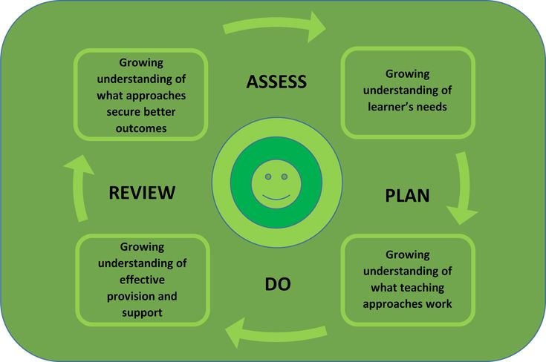

5.5 Supporting pupils moving between phases.
We will share information with the school or other setting the pupil is moving to as part of effective transition.

In F2, St Bridget’s supports the transition of pupils to the school by liaising with nursery or preschools. This transition will include professional meetings between the settings and observation of pupils by the F2 teacher. In addition to parents’ information evenings, taster sessions for pupils and a staggered start in September.

Transition from Primary to Secondary includes meetings between Year 6 teacher and each of the secondary schools St Bridget’s are feeding to, meeting between the SENCos, induction day for the pupils to attend their new schools and when needed, enhanced transition is arranged to support pupil with further need.

Transition between each year is also important. To ensure effective transition between years and key phases within St Bridget’s, time is allocated between staff for information to be shared, both pastoral and academic. Class swap over times are also organised after these staff transition meetings where the children have the opportunity to meet their new class teacher and spend some time in their new classroom.

5.6 Our approach to teaching pupils with SEND

Teachers are responsible and accountable for the progress and development of all the pupils in their class.
High quality teaching is our first step in responding to pupils who have SEND. This will be differentiated or personalised for individual pupils.

We will also provide the following interventions:
- Specialised Literacy Support
- Fine/Gross motor skills
- Handwriting
- Additional RWI support
- Clever Counting/additional maths support
- Precision teaching
- Resilient Friends/Circle of friends
- Lego Therapy
- School Counselling
- Time to Talk
- Social Cards
- Sensory Circuits
- CAMHS support
- ELSA

5.7 Adaptations to the curriculum and learning environment

We make the following adaptations to ensure all pupils’ needs are met:
- Differentiating our curriculum to ensure all pupils are able to access it, for example, by grouping, 1:1 work, teaching style, content of the lesson, etc.
- Adapting our resources and staffing
- Using recommended aids, such as laptops, ipads – specific apps to support teaching and learning e.g. Speechy, coloured overlays, visual timetables, larger font, etc.
- Making reasonable adjustments in the classroom to support learning, for example, giving longer processing times, pre-teaching of key vocabulary, reading instructions aloud/visual cues, using apps to support dictation and converting to text etc.
- The school has begun to develop a sensory room / calming area for children who become overwhelmed or distressed throughout the school day.
- The school is fully accessible to children with physical disabilities with 2 lifts, access ramps and a disabled toilet.
- We provide a gender neutral toileting facility.

5.8 Additional support for learning

We have teaching assistants who are trained to deliver interventions and support high quality teaching in the classroom.

We work with the following agencies to provide support for pupils with SEN:
- Community Paediatrician
- School nurse (0-19 Team)
- Occupational Therapist
- Physiotherapist
- Speech & Language Therapist
- Educational Psychologist
- Orrets Meadow
- Flourish (SEMH workshops)
- Kids Dot Calm (SEMH support)

5.9 Expertise and training of staff

Our SENCO, Mr Coughlin, is an experienced teacher who has taught in both Key Stage One and Key Stage Two.

He is allocated 2 days to manage SEN provision.

We have a team of teaching assistants, including three higher level teaching assistants (HLTAs) who are trained to deliver SEND provision.

Mrs Ross (Assistant Headteacher) supports the SENCO in developing specific TA training throughout the year to enhance skills and support QFT in the classroom.

In recent academic years, staff have been trained in precision teaching, growth mind-set, writing for greater depth, writing from a stimulus of high quality texts, phonics, mental health, team teach behaviour management, ASD and PDA support, Speech and Language.

We use specialist trained TA’s to provide spelling support.

Mrs King (trained ELSA) monitors and completes intervention in allocated hours where she helps both Pupil Premium and pupils with SEN in our school. Frequent meetings with Mr Le Feuvre and Mr Coughlin help to maintain a strong picture of how these pupils are progressing in our school. This also enables us to ensure looked after children with SEND are fully supported to reach their full potential.

5.10 Evaluating the effectiveness of SEND provision

We evaluate the effectiveness of provision for pupils with SEND by:
- Reviewing pupils’ individual progress towards their goals each term
- Reviewing the impact of interventions
- Using pupil questionnaires and pupil-centred plans
- Monitoring by the SENCO
- Using Edukey Provision Map to measure progress
- Holding annual reviews for pupils with statements of SEND or PFA/EHC/IHC plans. Parents evening also provides a chance for teachers and parents to review progress and take place twice annually.
- SENCO will provide an annual report to governors that discusses the effectiveness of SEN provision within school.

5.11 Enabling pupils with SEND to engage in activities available to those in the school who do not have SEN

- All of our extra-curricular activities and school visits are available to all our pupils, including our before-and after-school clubs.
- All pupils are encouraged to go on our residential trips
- All pupils are encouraged to take part in sports day/school plays/special workshops, etc.
- No pupil is ever excluded from taking part in these activities because of their SEND or disability.

5.12 Support for improving emotional and social development

We provide support for pupils to improve their emotional and social development in the following ways:
- Pupils with SEND are encouraged to be part of the school council and/or Eco and/or Ethos Committee
- Pupils with SEND are encouraged to be part of outdoor play
- Pupils with SEND are also encouraged to be part of clubs to promote team building and develop resilience.
- We have a zero tolerance approach to bullying.
- In order to identify where pupils are struggling with their mental health we will complete a Strengths and Difficulties Questionnaire (SDQ) or a Student Resilience Survey. This can highlight where pupils may need extra support.
- Once identified we have support TA who checks in on our vulnerable pupils. They can complete a variety of targeted tasks with pupils to help them access school.
- We work with a variety of external services such as Flourish, Kids Dot Calm and the Wirral Mental Health Team in order to provide short and long term emotional support to those who need it.

5.13 Complaints about SEND provision

Complaints about SEND provision in our school should be made to the Class Teacher or SENCo in the first instance. They will then be referred to the school’s complaints policy.

The parents of pupils with disabilities have the right to make disability discrimination claims to the first-tier SEND tribunal if they believe that our school has discriminated against their children. They can make a claim about alleged discrimination regarding:
- Exclusions
- Provision of education and associated services
- Making reasonable adjustments, including the provision of auxiliary aids and services

5.14 The local authority local offer

Our local authority’s local offer is published here: https://localofferwirral.org/

6. Monitoring arrangements

This policy and information report will be reviewed by the Senior Leadership Team every year. It will also be updated if any changes to the information are made during the year.

It will be approved by the governing board.

7. Links with other policies and documents

This policy links to our policies on:
- Accessibility plan
- Behaviour
- Anti-Bullying
- Equality information and objectives
- Supporting pupils with medical conditions
- Pupils with additional health needs attendance policy

