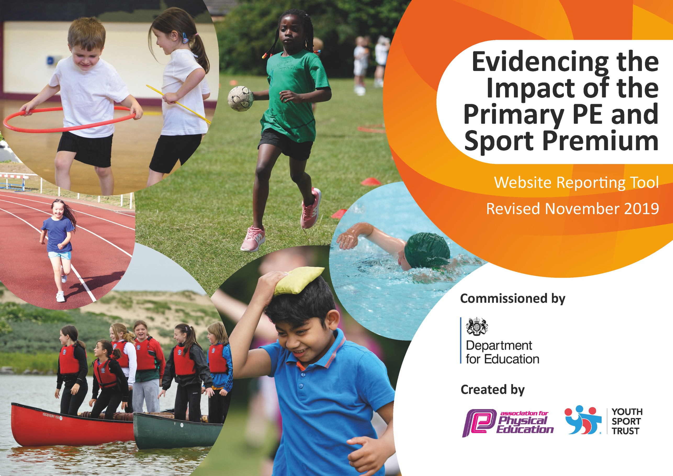
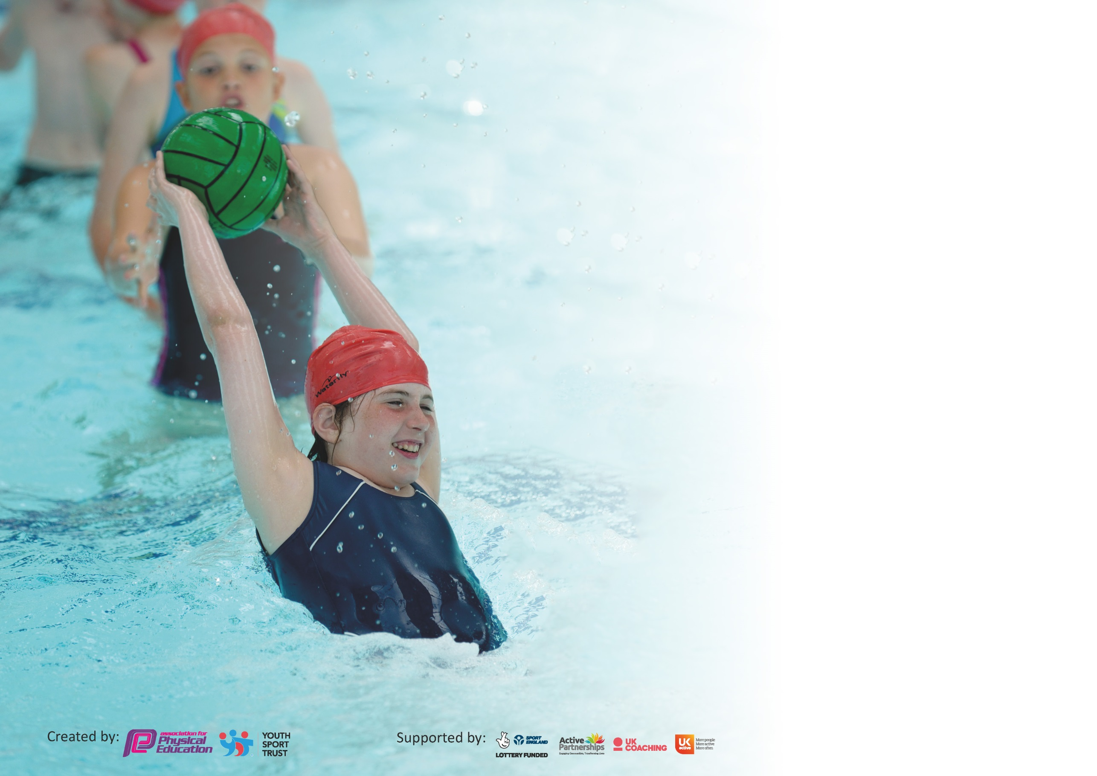

It is important that your grant is used effectively and based on school need. The Education Inspection Framework (Ofsted 2019 p64) makes clear there will be a focus on ‘whether leaders and those responsible for governors all understand their respective roles and perform these in a way that enhances the effectiveness of the school’.

Under the Quality of Education criteria (p41) inspectors consider the extent to which schools can articulate their curriculum (INTENT), construct their curriculum (IMPLEMENTATION) and demonstrate the outcomes which result (IMPACT).

To assist schools with common transferable language this template has been developed to utilise the same three headings which should make your plans easily transferable between working documents.

Schools must use the funding to make additional and sustainable improvements to the quality of Physical Education, School Sport and Physical Activity (PESSPA) they offer. This means that you should
use the Primary PE and Sport Premium to:

- Develop or add to the PESSPA activities that your school already offer
- Build capacity and capability within the school to ensure that improvements made now will benefit pupils joining the school in future years

Please visit gov.uk for the revised DfE guidance including the 5 key indicators across which schools should demonstrate an improvement. This document will help you to review your provision and to report your spend. DfE encourages schools to use this template as an effective way of meeting the reporting requirements of the Primary PE and Sport Premium.

We recommend you start by reflecting on the impact of current provision and reviewing the previous spend.

Schools are required to publish details of how they spend this funding as well as on the impact it has on pupils’ PE and sport participation and attainment by the end of the summer term or by 31st July 2020 at the latest.

We recommend regularly updating the table and publishing it on your website throughout the year. This evidences your ongoing self-evaluation of how you are using the funding to secure maximum, sustainable impact. Final copy must be posted on your website by the end of the academic year and no later than the 31st July 2020. To see an example of how to complete the table please click HERE.

Support for review and reflection - considering the 5 key indicators from DfE, what development needs are a priority for your setting and your pupils now and why? Use the space below to reflect on previous spend and key achievements and areas for development.

Key achievements to date until July 2022: | Areas for further improvement and baseline evidence of need:
School Gamesmark: Gold achieved for last 4 years up to 2019  Very popular extra-curricular clubs funded by PE Premium  (74% of KS2 children, 80% KS1/F2 children attended at least one course 2021-2022)  Opportunities for competitive sport beyond level 1. (46% KS2 chn represented St. Bridget’s 2021-2022) From Spring 1.  School Games Certification of Participation 2020  Evidence been submitted for School Games Mark- Gold Award achieved July 2022 | Using PE and physical activity to support overall wellbeing – Personal Best Programme- Years 2, 3 and 5.  Staff training: New/Movement of staff means staff are teaching PE for first time/ different age groups. CPD opportunities continued to support ECT staff 2022-2023.  Continue to target least active children to engage in physical activity through additional sessions and Wirral School Games activities.  Edsential Bespoke Package Purchased. Total £7317.75  PE Subject Leader Support  Fundamentals Programme- 2 slots EYFS.  Rainbow Project- Yoga based intervention-well-being support- Year 4 and Year 5.  New scheme of work and assessment for milestones.  Y5 Playmaker training- to be monitored by Edsential rather than deliver full training in 2023.

Meeting national curriculum requirements for swimming and water safety. | 63%
What percentage of your current Year 6 cohort swim competently, confidently and proficiently over a distance of at least 25 metres?  N.B. Even though your pupils may swim in another year please report on their attainment on leaving  primary school at the end of the summer term 2022. | 81%
What percentage of your current Year 6 cohort use a range of strokes effectively [for example, front crawl, backstroke and breaststroke]? | 71%
What percentage of your current Year 6 cohort perform safe self-rescue in different water-based situations? | 64%
Schools can choose to use the Primary PE and Sport Premium to provide additional provision for swimming but this must be for activity over and above the national curriculum requirements. Have you used it in this way? | Yes- Year 6 catch up lessons due to not swimming since Year 3.  £1896

Action Plan and Budget Tracking
Capture your intended annual spend against the 5 key indicators. Clarify the success criteria and evidence of impact that you intend to measure to evaluate for pupils today and for the future.

Academic Year: 2021/2022 | Total fund allocated:£19737 and £3674.25 under Spend from previous year.  Total spend: £23411.25 | Date Updated: 31/07/22
Key indicator 1: The engagement of all pupils in regular physical activity – Chief Medical Officer guidelines recommend that primary school pupils undertake at least 30 minutes of physical activity a day in school |  |  |  | Percentage of total allocation:
 |  |  |  | 12 %
Intent | Implementation |  | Impact | Spent £2736
Your school focus should be clear what you want the pupils to know and be able to do and about  what they need to learn and to  consolidate through practice: | Make sure your actions to achieve are linked to your intentions: | Funding allocated: | Evidence of impact: what do pupils now know and what can they now do? What has changed?: | Sustainability and suggested next steps:
Active play Activities to increase the number of pupils who are regularly active on the playground.  (Regular – 3 times a week) | Play Leader training will ensure that all children during lunch times have the opportunity to engage in structured physical activity. Edsential Training- Autumn 1  Starting with KS2- and then filtering down to KS1 (timing issue- review playtimes)  Resources/trollies have now been supplied for children to decide daily what activities to be completed.  Rota is in discussion with Year 6 pupils.  2 members of dedicated staff supplied. | £ 840 | Evidence -Subject Leader will monitor and evidence engagement with lunch time activities across the year.  Deputy Head- also monitoring participation of engagement.  Online tool to encourage Physical Activity. remembering physical activity does not replace Physical Education- See Google drive for examples.  Impact - KS1- has seen a positive increase of participants- lead by a member of staff and supported by year 2 active play leaders with EYFS and KS1. There is a designated activity every afternoon with a free flow accessibility and the rest of the playground areas are enhanced with sporting activities to encourage team work, fundamental skills and resilience.  KS2- Years 6 have actively embraced the roles and we have had a steady turn over of children volunteering to take part. Since covid restrictions have lifted children are now completing activities across key phases, sharing equipment and developing their own ideas. | Play leaders to train peers. More efficient use of playleaders leading games.  Evidence via photographs and pupil voice of participants and Yea 6 pupils.  Edsential support staff to check in- possible scope for additional support if needed- future keep in touch days arranged for next year rather than booking full training- This year’s staff will implement previous training and training next year 5 cohort reading to support active play in year 6.  To continue to raise the profile of active play, encourage peer on peer participate and transferable skills through interact, demonstration and practice. Introduce Sports Captain/Sporting Council.
Additional Year 6 swimming | Children have not swum since year3. Year 6 do not normally swim. Additional swimming lessons booked. | £1896 | Evidence – Swimming data reports  Impact – Data from 2018-2019 when children swam in year 3 last data was 25m 89%, Range of strokes 94%, Self-rescue 59% and 52% meeting NC.  A slight dip in percentages as 81% swimming 25m, Range of strokes 71 % and an increase of 6% in Self-Rescue 64%  64% of children achieving NC. | Year 6 children that have not achieved NC in Year 5 will participate in catch up swimming lessons during 2022-2023.  Subject Leader to look into fun engaging swim sessions to encourage water confidence, awareness and safety for non-swimmers across KS2.
Key indicator 2: The profile of PESSPA being raised across the school as a tool for whole school improvement |  |  |  | Percentage of total allocation:
 |  |  |  | 49%
Intent | Implementation |  | Impact | Spent £11362
Your school focus should be clear what you want the pupils to know and be able to do and about  what they need to learn and to  consolidate through practice: | Make sure your actions to achieve are linked to your intentions: | Funding allocated: | Evidence of impact: what do pupils now know and what can they now do? What has changed?: | Sustainability and suggested next steps:
Improve confidence and resilience in targeted groups by 90% compared to pre-intervention. | Personal Best: Years 2, 3 and 5.  To offer wide range of sporting opportunities to children for both physical and mental health benefits as well as personal development | Total cost. £3204 | Evidence - Baseline questioning before starting- same questioning when completed. - See Personal best data stored on school drive.  Impact -  Autumn-Year 2-Headline data report: 100% pupils feel more resilient after the programme  90% more confident.  Summer 1- Year 3- Headline report  84% more confident, 53% more confident and 91% enjoying physical activity.  Summer 2 year 5- Headline data report- 84% children feel more resilient, 91% enjoying physical activity and an increase of 90% confidence when taking part in physical activity. | Children physical and mentally healthy – resilient and engaged with learning.  Children adopt lifelong healthy lifestyles.  To develop a love of a sport and the confidence to strive to achieve the best- leading onto more areas of school and personal life.
Increase the number of pupils accessing intra and inter competitions with particular focus on pupil premium, SEND and our least active pupils.  Target of 50% of all KS2 pupils to represent the school in inter competitions- 46% represented since Spring 1, when Covid restrictions were lifted.  100% of pupils to take part in termly intra competitions. | Intra/Inter competitions commencing Spring 2022. Highlighting children not signing up for clubs- Focus on PP/SEND/FSM  Pupil Voice to monitor pupil feedback and inform future planning-.  Edsential assessment tracking system- in process of being designed. | Included in Edsential service  Wirral School Games comps. | Evidence - Registers of attendance at events will be used to measure impact in the Summer Term.  Feedback-verbal and pupil voice.  KS2 Inter compettions-46% represented since Spring 1, when Covid restrictions were lifted.  PP Pupils 10- 43% participation  SEND pupils-36% participation  FSM puipls-67% participation | To embed and develop a love of potential sport. To increase participation.  Making sporting activities accessible to all.  To complete the assessment tracker and deliver to staff- Edsential support to deliver staff training.
Improve the fundamental movement skills of pupils in EYFS. Target of 80% of all FS2 Pupils to reach GLD in Physical development. | To baseline children’s fundamental skills at the beginning of EYFS. Due to covid- fine and gross motor skills development.  Use FUNdamentals intervention programme for targeted groups with a focus on gross motor skills. | £1728 | Evidence – Data and Impact Reports  Impact - Children developed skills throughout the 6-week programme. Catching, throwing, jumping, agility, speed and safety.  Autumn 2 report Headline- Agility and Running - During the first assessment, it was obvious that the children were very confident in safely negotiating the space around them.  Co-ordination skills were highlighted as having the biggest impact on the children. 10 children initially demonstrating good coordination and after completing the programme 45 children. See report saved to the school drive.  Summer 2 Headline report- Highlighted from baseline that throwing and catching was an area of development- initially 8 children from the cohort demonstrated catching well after completing the programme 51 children met the target. Throwing- initially 10 children demonstrated throwing well after completing the programme 50 children demonstrating accuracy when throwing. - Report on school G.drive  Headline report- Summer data 97% of children achieving GLD in PE. | Staff completed assessments and team taught with the coach. Transferable skill set.  CPD support by Edsential online lesson plans.  Fundamental skills programme to be repeated in the summer term to assess progress.  CPD booked for Autumn term to be completed with the new EYFS cohort but to be redelivered in Summer 1 by staff supported by Edsential scheme of work.
Continue Rainbow project to ks1 and KS2. It is a blend of yoga and mindfulness and self-regulating techniques.  Outcomes: Develop and improve  Resilience  Self-Awareness  Positive Mental Health | Ks1&2 staff will stay in for CPD Weekly hour session sessions-whole class for 12 weeks. Class teacher is given tasks that can be completed within the classroom environment. | £4080  £2350 | Evidence - See Impact Report  Impact – significant improvement in self-awareness and positive mental health (30%+ showed improvements). | Staff will be able to roll out the programme at no cost next year as they have the CPD and additional course material. Transferable skill set.  Rainbow project to be delivered to another year group and staff to be trained in the skill set for future delivery- delivery in 2022-2023

Key indicator 3: Increased confidence, knowledge and skills of all staff in teaching PE and sport |  |  |  | Percentage of total allocation:
 |  |  |  | 31%
Intent | Implementation |  | Impact | Spent £7236
Your school focus should be clear | Make sure your actions to | Funding | Evidence of impact: what do | Sustainability and suggested
what you want the pupils to know | achieve are linked to your | allocated: | pupils now know and what | next steps:
and be able to do and about | intentions: |  | can they now do? What has
what they need to learn and to |  |  | changed?:
consolidate through practice:
Increase confidence and competence of staff to teach high quality physical education = increase in the number of pupils achieving NC standards | Staff CPD Swimming teaching 2-day course | £624 | Evidence – Swimming data reports  Impact –  Meeting National Curriculum: -  Year 3- 47%  Year 4-46%  Year 5-57%  Year 6-63%  Across the school, we are in line nationally with 72% meeting the objective to swim 25m; range of strokes 74% meeting the objective as opposed to 34% nationally and self-rescue at 56% in line with the national percentages. | 4 more staff now with up to date qualifications.
Increase pupil attainment in curriculum PE | Access Subject leader training/conferences & updates as available during the year including regular meeting to monitor curriculum design.  CPD sessions with PE specialist using identifying areas for development | Supply £400 for Subject leader to attend.  £890 – Subject Leader Support  £3204- CPD sessions.  £1830 | Impact - Subject Leader up-to-date with information needed for curriculum improvement/development and sporting opportunities available.  Improved confidence and competence of staff to teach PE  Impact evident in all other areas of this document. | PE Subject Leader monitor and provide support as appropriate in order to ensure progress and achievement are maintained by all pupils.  Main focus on training ECT staff- additional CPD booked for 2022-2023 in staff highlighted areas of development.  Area of development is 0AA in KS2- staff to receive CPD training from Edsential to be delivered in 2022-2023- Year groups to be determined in September 2022.
To access a sequential curriculum, using the National curriculum and the Milestones as the driver. | All staff to be aware of and use the new Edsential scheme of work- online plans.  Introduce/made aware of the progression tables to make sure that progress is being seen across the school- linked to milestones and threshold concepts. | SOW- 288 | Curriculum design, professional development and assessment design.  Progression of skills through each key stage.  Impact - Staff feedback- on how effective plans are, impact on teaching and how accessible.  Plans are very effective and staff are finding them easy to use- plans have been used to create medium term planning with outcomes clearly defined. | Staff feedback- on how effective plans are, impact on teaching and how accessibility.  Plans are very effective and staff are finding them easy to use- plans have been used to create medium term planning with outcomes clearly defined. Using the outcomes, as a school we intend to introduce PE floor books to evidence the impact of Thinking, Physical, Healthy Active Lifestyles and Social and Emotional development- links to PHSE.
Key indicator 4: Broader experience of a range of sports and activities offered to all pupils |  |  |  | Percentage of total allocation:
 |  |  |  | 6%
Intent | Implementation |  | Impact | Spent £1577.25
Your school focus should be clear | Make sure your actions to | Funding | Evidence of impact: what do | Sustainability and suggested
what you want the pupils to know | achieve are linked to your | allocated: | pupils now know and what | next steps:
and be able to do and about | intentions: |  | can they now do? What has
what they need to learn and to |  |  | changed?
consolidate through practice:
Increase the range of activities available at lunchtimes  Increase the number of pupils who are regularly active on the playground.  (Regular – 3 times a week)  Target of 85% in KS1 and 70% in KS2  Retain high percentage of children participating in breakfast and after school clubs | Lunch time engagement – Play Leaders will ensure that throughout the year, children are given the opportunity to take part in a broad range of activities during lunch times.  EYFS/KS1/KS2 Active play equipment has been purchased. FS2 a selection of balance bikes and storage to enable core strength, balance and agility.  Edsential package- extra-curricular courses.  Pupil questionnaire- ownership on what clubs the children would like to see offered. | Playleader Award £840- allocated in indictor 1  £708.59- money left over from payments for clubs- not in total spends for this year.  £1169.85  407.40- additional EYFS/KS1 resources  £4680- PAID for last year not in total spends for this year. | Evidence - Subject Leader observations and Pupil Voice will be used to measure the impact of Play Leaders on engagement.  Impact - Raising the profile of physical activity during playtimes- children have free choice of equipment they would like to use- monitored and implemented by active play leaders, over seen by a member of staff.  97% of children achieving GLD in the EYFS- 99% achieving GLD in gross motor skills.  High amounts of participation.  Target to have at least 70% of ks1 and KS2 children- actual percentage 80% of KS1 and actual percentage 74% of KS2.  Impact - Children have decided what clubs were to run this year, this was completed by a pupil voice for each year group-a variety of clubs offered to meet the preference of children- Edsential very accommodating.  Developing interest for potential out of school experiences.  Making links with external providers.  Uptake very high increased number of clubs taking place from 2 a week to 3 clubs running a week delivered by Edsential. | Playmaker award for further training and involvement of the children.  Increase in staff run clubs for free where willing.  Children to take ownership of looking after equipment, storing properly and to actively engage and create own open-ended activities.  To purchase more bikes in the future to be used across the whole of KS1- cultural capital gains as some children may not have access to a 2 wheeled bike or the opportunities to ride a bike outside of the school environment.  Continue to monitor participation and pupil voice for possible clubs.  Making links and connections with other outside agencies.  To continue with the increased clubs and to run at least 2 additional outside agency clubs.  To continue to monitor outside clubs’ children attend during out of school hours via Google forms to parents, to collate results and add to participation tracker.

Key indicator 5: Increased participation in competitive sport |  |  |  | Percentage of total allocation:
 |  |  |  | 2%
Intent | Implementation |  | Impact | Spent £500
Your school focus should be clear | Make sure your actions to | Funding | Evidence of impact: what do | Sustainability and suggested
what you want the pupils to know | achieve are linked to your | allocated: | pupils now know and what | next steps:
and be able to do and about | intentions: |  | can they now do? What has
what they need to learn and to |  |  | changed?:
consolidate through practice:
School games award.  Intra/Inter competitions commencing Spring 2022. Highlighting children not signing up for clubs- Focus on PP/SEND/FSM  Increase the number of pupils accessing intra and inter competitions with particular focus on pupil premium, SEND and our least active pupils.  46% of all KS2 pupils to represent the school in inter competitions  100% of pupils to take part in termly intra competitions. | Intra/Inter competitions commencing Spring 2022. Highlighting children not signing up for clubs- Focus on PP/SEND/FSM | £500- supply cost due to class teacher taking clubs out Wednesday pms to attend clubs. | Inclusion for all children- no barriers.  Impact to be measured once competitions commence.  Due to Covid restrictions and staff shortages to access inter competitions are target was 50% of KS2 children to attend competitions. As a school we did not start to participate in inter competitions until early Spring 1, we achieved 46% of KS2 children participating. We are very happy with this result, given the challenging circumstances | Continue to track ‘zero children’/PP/SEND and target them with opportunities as far as possible within school time or with transport provided by school.  To raise the profile of attending competitions through Wirral school Games and Edsential competitions from Autumn 1 2022 and to ensure we are using the pupil tracker to make all sporting activities accessible to all.

Signed off by
Head Teacher: | Neil LeFeurve
Date: | 22/07/2022
Subject Leader: | L Ashton
Date: | 21/07/2022
Governor: | C Morgan
Date: | 31/07/2022

