For weeks beginning 1st June, 8th June and 15th June (3 weeks)
Theme Zoo / Rainforests
Example discover and do activities
- Learning facts about animals that live in the zoo or rainforest.
- Learn about palm oil and what happens to the rainforests and animals that live there – There will be a video uploaded on tapestry to help you with this.
- Zoo and rainforest crafts – See photographs for examples
- Zoo / rainforest paintings and collages – See Photographs
- Giraffe Coffee Art- – A tapestry video will be uploaded to explain this and give examples.
- Observational drawings zoo animals
- Learning about the role of a zoo keeper – Chester zoo have done virtual tours of the zoo since lockdown has been happening – They are well worth a visit and the children can lots of facts and information from the video links - https://www.chesterzoo.org/virtual-zoo-2/
- Small world zoo – communication and language and role play
- Create their own rainforest creature – A tapestry video will be uploaded to explain this and give examples.
Please continue to give your child plenty of time to play from their own child initiated choice – favourite construction, dressing up, role play, make music, sing, dance, small world, playdough, painting, drawing, water play, sand play (if you have it accessible), physical activity- throwing and catching a ball, running, hopping, skipping, riding bikes or scooters.
Example writing for purposes linked to theme
- Zoo or rainforest animal fact sheet
- Rhyming animal reading challenge (See attached worksheet)
- Write about their own rainforest animal (Linked to a tapestry video)
- Design a map of a zoo and write labels, directions and signposts. For example - See the elephants here. This way to the giraffes. Stop and look at the lions. Do not feed the tiger. Put your rubbish in the bin. etc.
- Persuasive poster writing to save the orangutans and raise awareness about sustainable palm oil - (Linked to a tapestry video)
- Children to look closely at the pobble (See attached picture) what can they see – can the children label it, write sentences about it (number of sentences dependent on your child’s ability) or perhaps they can use their imagination and create a story about it.
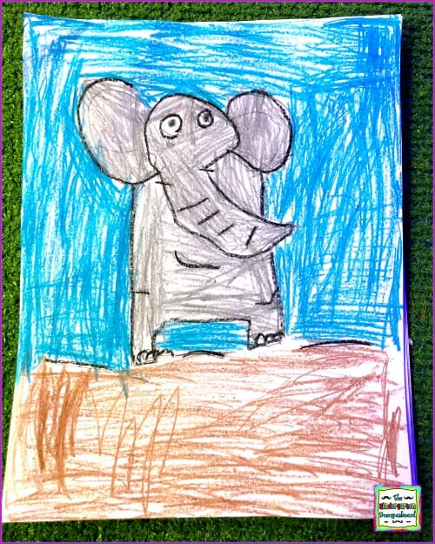
- Story writing – (Linked to a tapestry video)
Children should still be encouraged to write about their own interests – for example labelling or sentence writing about a model they have made with the lego, writing about their favourite toy / character, writing a menu for teatime or recipe for baking.
Daily set up for phonics sessions
- Choose a sound to focus on, look at the last sound your child was taught in school and work your way through the list.
- We recommend one or two sounds a week and focus on mastering those sounds before racing on.
- Recognition of the sound and rhyme.
- Read words and sentences with this sound.
- Speed write the new sounds lots of times repeating and over.
- Speed write 2 previous sounds over and over.
- Write at least 3 words including this new sound. Write each word at least 3 times.
- Write a caption or sentence including grotty words and a word with this new sound.
There will also be lots of phonic recaps and challenges being uploaded on tapestry weekly.
Children should now be able to hold the word / sentence in their head and write them independently.
Maths ideas:
Consolidation- Numbers to 20. See ELG specific areas expected and exceeding statements.
Consolidation shape, space and measure. See ELG specific areas expected and exceeding statements.
- Accurately counting to 20 forwards and backwards.
- Number game- counting to 20 and say stop at any given number and ask your child to count forwards or backwards.
- My turn your turn counting to 20. Adult says ‘1’ and child says ‘2’ and so on- extra challenge Don’t say the number 20! How long can you carry the game on? Extra extra challenge- can you do it from 20-0?
- Flash number cards 1-20 randomly. Can you order your flashcards? Can you point to a number and say which number is one more or one less? Without using a number line or flashcard cards can you say 1 more one less than a random number to 10? 20?
- Accurately counting of amounts to 20- careful finger pointing whilst saying the number name to accurately count.
- Counting in 10’s to 100
- Counting in 5’s to 50
- Counting in 2’s to 20

- Race to 20 game- Each player will need 20 counters/ items (pasta, coins, any small loose parts) You will need to make a number track or print the one provided in the resources and a dice. You take it in turns to roll the dice, if you roll 1 - 5 , you collect the corresponding counters/ items to fill the track. If you roll a six you clear the track and start again. Who will fill their track first?

- Practise subitising amounts. Can you see the patterns in the numbers to know how many there are without having to count them out? Watch you tube clips Jack Hartman Subitising songs.

- Print out or make your own subitising flashcards. Can you recognise the amounts on all of the cards? Challenge- can you time how long it takes you to recognise all the flashcards. Can you beat your time? Can you have a competition with someone from your family? Can they beat your time or vice-versa? You could FaceTime a relative and challenge them!
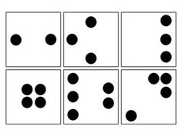
An example of subitising cards- flashcards included in resource page.

- Can you make playdough and measure the amounts carefully? You will need 1 full cup of flour, 1 full cup of salt and half a cup of water. Add the flour and salt and slowly add in the water and combine/mix your ingredients. Once made can you mould and manipulate the dough into the 3d shapes that you know?
- Using your dough can you find some loose parts from around your home and push them into the dough to create a repeating pattern. For example, a bottle top, dice, a bottle top, a dice.
- Clapping/movement patterns- can you clap a pattern/rhythm and your child repeat it back Eg- clap, knees, clap, knees or clap clap, knees, clap clap, knees. Eg- punch to the side, drop to the ground, punch to the side then drop to the ground. Be as creative as you like. Could you record your patterns and send them to use on Tapestry?
Movement - Extra challenge can you add a piece of music to it, for example Queen
we will rock you or The Greatest Showman.

- Can you create your own repeating pattern?
Once your child has made their pattern, ask them what is the repeating part? They might say colour, shape or number. This is an AB pattern, there is 2 components to the pattern-
Challenge- Can your child make an AAB pattern? AABB pattern? Or even an ABC repeating pattern?
Example of an AABB pattern.
A pattern does not always have to have a shape or a colour, why not make a repeating pattern with some of our phonics sounds- Eg ai, ee, igh, ai, ee, igh.
- Estimation- What does estimation mean? We make a sensible guess! Not a silly guess. We look, estimate the amount and then make a sensible guess/estimate.
- In containers or bowls can you place amounts of any items inside. It could be grapes, sweets, pasta again any loose parts. Let your child look for a couple of seconds and then cover up the container. Ask them to estimate how many items they think where inside. Can they write their guess in their journals, and then can they find out how many were actually there in total by carefully counting out? Can they record the actual total? (They could even draw the container with their estimate and draw the container with the actual amount. This is called mathematical graphics) Can they also show their thinking by working out how many their guess was out by? Was their guess quiet accurate, not very accurate or spot on! Firstly, start off with numbers to 10, then build up to 20.
- Addition and Subtraction word problems. Can you create word problems for your children using the word structure of- First, then, now.
For example, first there were 7 people on the bus, then 3 more got on, how many are there now on the bus?
- During your child’s play, can you encourage your child to create their own first, now, then stories? For example, First there where 7 dolls in the house, then 2 went to play in the garden, now there are 5 dolls in the house. First I have 12 marbles, then I send 3 down the marble run, now I have 9 left.
- Can you encourage your children to create their own problems, can they create their own simple maths stories to practise adding and taking away? They can use mathematical graphics (drawings) and you can annotate their story (their thinking) repeating if necessary the language First, then, now. If your child is able, they can write their own mathematical story.
- Can your child journal their thinking to their mathematical story, by using a part, part whole? Number sentence? Number line?
- Data handling- Investigation, can you find out what animal is the most favourite in your family/ extended family- Can you make calls/ face times to contact other friends and family. Make a list of animals, and ask your family members which animal is their favourite. Can you record your findings and make a tally chart? Remember if you get 5 we put a gate on the tally. Check your results. Which animal was the most favourite and which animal was the least. Xan you order your findings? Most favourite to least and least favourite to most. Remember your ordinal numbers 1st 2nd 3rd…etc. A blank record sheet is included on the resources if you would like to use it or look at the layout.

Miss Daltrey, Miss Cotterell and Mrs Darby will be updating the Memos tab on Tapestry with videos and challenges to enhance your child’s learning. The videos will there to access all the time. They will complement the activities above, and you can see how we structure, language used to deliver lessons and layer the teaching opportunities and activities.
Thank you for your hard work, on-going support and perseverance with home learning.
Well wishes.
The Foundation Stage Team
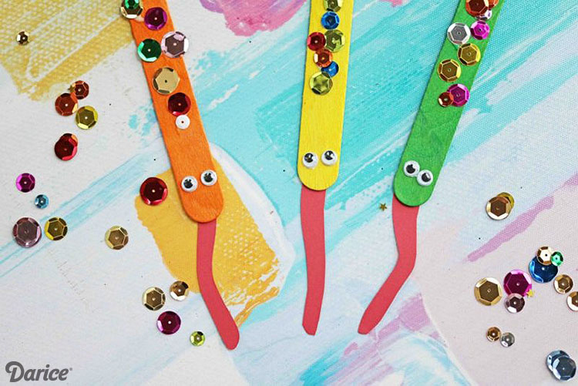
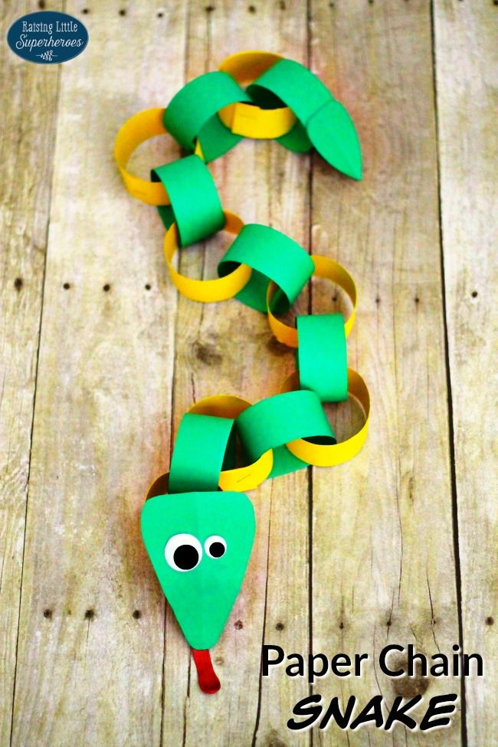
Craft ideas:

