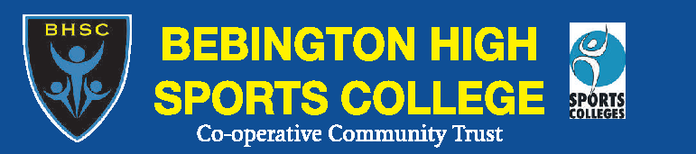

TUES 19th – THURS 21ST FEBRUARY 2013
E

Bebington High Sports College working in partnership with
Liverpool Football Club Premier League 4 Sport

ONLY £25.00!

****SPECIAL OFFER:
Each additional sibling receives
20% DISCOUNT

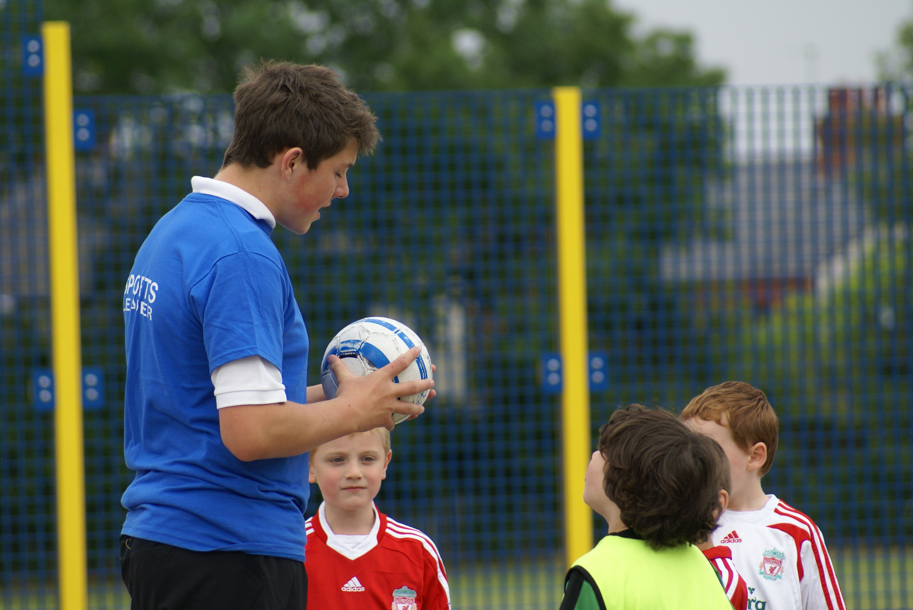
Boys & Girls
Aged 7-12 years
9.30 – 3.00pm

ALL COACHES FULLY QUALIFIED AND CRB CHECKED

Contact: Craig Nall
0151 645 4154
or email
craignall08@yahoo.co.uk
Safe, fun, and progressive recreational multi-sports sessions, including Football, Basketball, Dance, Rugby, Cricket and many more subject to demand!

